**Real-Time Suspicious Fall Event Detection**

A PROJECT REPORT

1. Mohammad Abdulla

mohammadabdulla20march@gmail.com

**ABSTRACT**

Falls are a leading cause of injury and mortality among the elderly and individuals with physical impairments, and the lack of immediate response in such cases can lead to severe medical consequences. This project presents a real-time, AI-driven fall detection and alerting system that utilizes computer vision, deep learning, and facial recognition technologies to identify fall incidents and immediately notify caregivers. The system is built using a modular architecture, integrating the YOLOv8 object detection model for posture-based fall detection, enhanced with Farneback optical flow to analyze sudden motion dynamics preceding a fall. A dual-threshold logic is applied to differentiate between normal and suspicious falls, ensuring accurate classification with minimized false positives.

To provide personalized alerts, the system includes a facial recognition module using DeepFace, which identifies the individual involved in the fall and retrieves their registered emergency contact. Upon verification, the system triggers both a local sound alert and an automated SMS via the Twilio API to the caregiver or relative. A user-friendly interface built using Streamlit allows for secure profile registration, camera feed analysis, and system configuration.

The proposed system was thoroughly tested across diverse environments and demonstrated high accuracy, responsiveness, and real-time performance. It provides an accessible and scalable solution for fall detection in homes, eldercare centers, and healthcare institutions. Future enhancements may include predictive analytics using pose estimation, cloud deployment for multi-camera support, and integration with IoT devices to create a comprehensive safety and wellness monitoring framework. This project represents a meaningful step toward using AI not just for automation, but for enhancing human safety and quality of life

**TABLE OF CONTENTS**

**Page No.**

ACKNOWLEDGEMENTS iii

ABSTRACT iv

LIST OF FIGURES vi

LIST OF TABLES vii

CHAPTER 1- INTRODUCTION 7

* 1. MOTIVATION 7
  2. PROBLEM STATEMENT 8
  3. OBJECTIVES AND SCOPE 9
  4. PROPOSED SYSTEM AND METHODOLOGY`` 10
  5. RELEVANCE AND APPLICATIONS 11

CHAPTER 2 – LITERATURE SURVEY 11

* 1. EVOLUTION OF FALL DETECTION SYSTEMS 13
  2. DEEP LEARNING APPROACHES IN FALL DETECTION 14
  3. CONTEXTUAL ANALYSIS USING OPTICAL FLOW 15
  4. FACE RECOGNITION FOR PERSONALIZED ALERTS 16
  5. COMMUNICATION TECHNOLOGIES 17

CHAPTER 3 – SYSTEM SPECIFICATIONS 15

* 1. TECHNICAL FOUNDATIONS AND ARCHITECTURE 19

CHAPTER 4 – SYSTEM DESIGN 24

CHAPTER 5 – SYSTEM IMPLEMENTATION 31

* 1. MODULES USED WITH DESCRIPTION 31

CHAPTER 6 – SYSTEM TESTING 35

6.1 USER INTERFACE TESTING 37

6.2 LIVE MONITORING & REAL-TIME FALL 39

6.3 ALERT SYSTEM VALIDATION 40

CHAPTER 7 – RESULTS AND ANALYSIS 44

CHAPTER 8 – CONCLUSION AND FUTURE ENHANCEMENT 50

REFERENCES 55

**LIST OF FIGURES**

Fig. 4.1 User Interface

**Figure 4.2: Fall Detection Core**

**CHAPTER - 1**

**INTRODUCTION**

* 1. **Motivation and Background**

The evolution of intelligent systems has significantly reshaped modern healthcare, especially in the domain of real-time monitoring and emergency detection. Among the various health challenges that aging populations face, falls have emerged as one of the leading causes of accidental injury and mortality worldwide. According to statistics by the World Health Organization (WHO), nearly 37.3 million falls are severe enough to require medical attention annually, with older adults being particularly vulnerable. In many cases, the inability to receive immediate help following a fall exacerbates the condition, leading to prolonged recovery, loss of independence, or even fatality. These alarming figures serve as a compelling motivation for the development of smart, automated fall detection systems that can operate continuously, accurately, and autonomously.

Traditional fall detection approaches rely primarily on wearable sensors such as accelerometers and gyroscopes, which, while effective in controlled conditions, suffer from practical limitations in real-world usage. Elderly individuals may forget to wear these devices, find them uncomfortable, or refuse them due to privacy concerns. To address these limitations, computer vision-based solutions have emerged as a promising alternative, offering non-intrusive surveillance using regular camera setups. In this context, our project explores a multi-modal, vision-based fall detection framework that integrates deep learning models, facial recognition, and movement analysis techniques to ensure reliability and personalization.

The overarching aim of this project is to detect falls accurately in real-time, identify the person involved using facial recognition, and notify an emergency contact via SMS without manual intervention. This solution significantly reduces the time between a fall event and response, potentially saving lives and enhancing the quality of care for at-risk individuals. The system is built to be scalable, cost-effective, and deployable in residential homes, nursing centers, and hospitals. It integrates technological precision with human-centric design principles to create a practical safety application for everyday use.

**1.2 Problem Statement**

Despite advancements in fall detection research, existing systems often fall short when deployed in dynamic, real-world settings. Sensor-based devices require human cooperation, while vision-based models struggle with environmental variables such as lighting, occlusion, and camera angles. Moreover, many existing models lack the ability to personalize alerts or validate the identity of the individual who has fallen. This increases the risk of false positives or generalized responses, which can lead to alert fatigue or miscommunication during actual emergencies.

The key challenges that motivated our work are: (1) how to detect falls with high accuracy using video input alone, (2) how to differentiate between normal and suspicious falls based on context, movement, and body posture, (3) how to verify the identity of the person using face recognition without relying on wearable devices, and (4) how to ensure timely notification using a robust communication channel like SMS. These challenges form the backbone of our problem space, around which we have designed and implemented a comprehensive fall detection and alerting system.

To achieve this, we utilized the YOLOv8 object detection model for its proven accuracy and speed in real-time object detection tasks. This model is capable of detecting human postures that resemble a fall, with different confidence thresholds set to distinguish between normal and suspicious incidents. Furthermore, optical flow techniques are used to track sudden movement patterns before a fall occurs. To provide personalization and context, we used DeepFace to recognize the face of the person involved, ensuring the alert is sent to the right emergency contact. The Twilio API was then integrated to trigger instant SMS notifications, making the entire system reactive and communicative.

**1.3 Objectives and Scope**

The primary objective of this project is to design and implement a robust fall detection system that leverages modern machine learning and computer vision techniques. The system should be capable of analyzing video feeds—either in real time from a webcam or through pre-recorded video files—and detect falls with a high degree of accuracy. Upon detection, it should trigger appropriate alerts, including sound and SMS, and identify the individual involved if a face is visible. This multi-layered approach combines fall classification, face verification, movement analysis, and alert generation into a unified pipeline.

The scope of this project extends to both technical and practical domains. Technically, the system employs YOLOv8 for fall detection, TensorFlow-based models for feature extraction, and OpenCV for video processing. Facial recognition is achieved using DeepFace, which provides robust face embedding and matching capabilities. From a practical standpoint, the system has a Streamlit-based graphical interface for administrators to register new profiles, capture or upload facial images, manage emergency contacts, and monitor fall events. This makes the system highly user-friendly and applicable in real-world environments.

Additionally, the system is designed with scalability and modularity in mind. Frame-skipping and session-based state tracking are implemented to optimize computational efficiency without compromising accuracy. Different types of fall scenarios, such as sudden collapses or slow descents, are accounted for using adjustable thresholds. The inclusion of movement analysis prior to a fall detection further improves the reliability of alerts by filtering out false positives triggered by gestures or unusual postures. The SMS module ensures real-time communication, which is especially vital in scenarios where quick human intervention can make a significant difference.

**1.4 Proposed System and Methodology**

The proposed system is built around an end-to-end processing pipeline that integrates video analysis, identity recognition, movement detection, and alerting mechanisms. It begins with capturing a video stream, which can either be uploaded by the user or streamed live via a webcam. The frames are processed in intervals (every 5th frame) to optimize performance without losing temporal relevance. These frames are passed through the YOLOv8 model, trained on a custom dataset, to detect fall instances. The model classifies the detected instances as either "Normal Fall" or "Suspicious Fall" based on confidence thresholds—falls above 0.85 or with detected motion spikes are marked as suspicious.

The methodology includes an intelligent movement analysis module that uses Farneback's optical flow algorithm to compute changes in pixel intensity across frames. This allows the system to identify sudden shifts in body motion that are often precursors to falls. If such movement is observed prior to a YOLO-based fall detection, it strengthens the classification and marks it as suspicious, thus enhancing reliability.

Simultaneously, the face in the frame is analyzed using DeepFace to generate embeddings, which are compared with previously stored profile embeddings. If a match is found (cosine similarity > 0.7), the system retrieves the user’s information such as name, age, and emergency contact. These personalized details are then used to compose a custom SMS message via Twilio, indicating the nature of the fall and the identity of the person involved. This message is sent immediately to the registered phone number, allowing caregivers or family members to take timely action.

The interface developed using Streamlit facilitates profile management. Users can register by entering personal details and uploading or capturing a photograph. This image is used to generate embeddings for later facial recognition. Administrators can securely log in using predefined credentials to manage profiles, start or stop video feeds, and monitor alert logs. The system is structured in such a way that even non-technical users can operate it efficiently.

**1.5 Relevance and Applications**

The significance of the fall detection system lies in its real-world applicability, especially in environments where elderly or at-risk individuals require constant monitoring. In homes, the system can serve as a 24/7 guardian, reducing the need for human supervision and ensuring immediate response in case of emergencies. In hospitals and eldercare facilities, the system can be integrated into existing security infrastructure to provide an additional layer of patient safety. It is particularly useful during nighttime or in understaffed situations, where human intervention may be delayed. Furthermore, the system’s modularity allows it to be extended to multi-camera setups and integrated with centralized dashboards for large-scale deployments.

Beyond medical and eldercare applications, the system has potential uses in industrial safety, rehabilitation centers, and surveillance. Factory floors, for example, pose several risks to workers who may experience accidental falls. Integrating such a fall detection system into CCTV networks can enhance occupational safety protocols. Additionally, the solution can be adapted for use in smart homes, where it can trigger home automation routines in response to fall events—such as turning on lights, unlocking doors for emergency responders, or alerting nearby caretakers.

In the broader context of AI in healthcare, this project aligns with the trend of developing context-aware systems that combine perception, cognition, and communication. By merging computer vision with human-centered alerting mechanisms, the proposed solution serves as a model for ethical and impactful AI deployment. It demonstrates how intelligent systems can augment human capabilities, mitigate risks, and contribute to the overall well-being of society.

**CHAPTER - 2**

**LITERATURE REVIEW**

### ****2.1 Evolution of Fall Detection Systems****

Fall detection has become an increasingly important area of research due to the rapidly aging global population and the consequent rise in age-related health risks. The earliest attempts at automated fall detection predominantly employed **wearable sensor technologies** that made use of accelerometers, gyroscopes, and magnetometers to detect sudden changes in body orientation or velocity. These devices were lightweight, portable, and could provide real-time monitoring, making them an attractive solution in controlled environments. However, their effectiveness in real-world settings was limited by challenges such as user compliance, false positives triggered by regular movements, and signal drift over time. Research by Mubashir et al. [1] emphasizes that although wearable devices achieve high accuracy in laboratory settings, they often suffer from poor user adherence and require constant charging and calibration, reducing their practicality in elderly care scenarios.

To overcome these limitations, researchers turned to **ambient-based sensing techniques**, which use external devices such as floor vibration sensors, infrared motion detectors, and pressure sensors embedded in furniture or flooring. These systems are less intrusive and do not rely on the subject’s participation, but they require complex installation and often suffer from occlusion or spatial limitation issues. Moreover, such systems are environment-specific and do not generalize well across different types of rooms or architectural layouts. Works by Sixsmith and Johnson [2] discussed the early use of pressure-sensitive floor mats and infrared sensors to detect changes in weight distribution and movement. However, these systems struggled to distinguish between fall-like events (such as quickly sitting down) and actual falls, leading to significant inaccuracies.

With advancements in image processing and the increasing affordability of cameras, **vision-based systems** emerged as a promising alternative. Early computer vision approaches for fall detection relied on static background subtraction, motion tracking, and rule-based heuristics to identify anomalies in posture and trajectory. For instance, Anderson et al. [3] used a single overhead camera to track the aspect ratio of a person’s bounding box to detect when they were lying on the floor. While such systems were an improvement, they were sensitive to lighting conditions, shadows, and occlusions, which are common in household environments. Moreover, these techniques lacked generalizability and were limited in their ability to recognize different types of falls, such as slow descents or backward collapses.

### ****2.2 Deep Learning Approaches in Fall Detection****

The advent of deep learning marked a paradigm shift in fall detection research. Convolutional Neural Networks (CNNs), Recurrent Neural Networks (RNNs), and hybrid models brought a new level of feature abstraction and pattern recognition that was previously unattaina

ble through traditional methods. Deep learning models can automatically learn spatial and temporal patterns from large-scale video data, enabling the system to distinguish between fall and non-fall actions with minimal manual feature engineering.

One of the most notable developments in this domain was the integration of CNNs for frame-level feature extraction combined with Long Short-Term Memory (LSTM) networks for temporal sequence modeling. Works such as that of Ma et al. [4] demonstrated that combining CNNs with LSTMs allows the system to capture both visual context and motion continuity, significantly improving fall classification performance. The model could distinguish between similar actions such as sitting down quickly and collapsing, which are often misclassified by traditional systems.

However, the biggest breakthrough came with the application of **YOLO (You Only Look Once)** object detection models. YOLO-v3 and later versions, like YOLOv5 and YOLOv8, introduced high-speed, accurate real-time object classification capabilities. The works of Redmon et al. [5] laid the foundation for object detection in real-time applications, and their subsequent adaptations were applied in healthcare for human posture recognition and fall detection. YOLO-based systems outperform many other architectures in speed and efficiency, making them suitable for real-time deployment on edge devices. More recent research has fine-tuned YOLO for fall detection by training on specialized datasets containing various fall scenarios from multiple camera angles.

Our proposed system utilizes YOLOv8, one of the most advanced iterations of the YOLO architecture, trained on a curated dataset of fall and non-fall instances. This enables the system to recognize specific poses and fall trajectories based on bounding box patterns and confidence scores. The incorporation of **dual-threshold logic** (normal vs. suspicious fall) further refines the accuracy and contextual relevance of the detections. This literature-backed approach forms the core vision module of our system.

### ****2.3 Movement and Contextual Analysis Using Optical Flow****

Despite the progress in object detection and classification, many models still misclassify normal activities as falls, especially in scenarios involving rapid movements, sitting, or bending. This has driven researchers to supplement spatial models with **motion-based analysis techniques**. Optical flow is one such technique that estimates the apparent motion between consecutive video frames based on pixel intensity changes. When used in conjunction with object detection, optical flow can provide valuable context about the nature and velocity of movements leading up to and following a fall.

Farneback’s algorithm is one of the most commonly used methods for dense optical flow estimation. The research by Szeliski [6] details how optical flow has been used extensively in human action recognition tasks. In the context of fall detection, Wang et al. [7] used optical flow vectors to track rapid limb movement and acceleration prior to a fall. These motion signatures were then mapped onto fall probability scores. This hybrid method proved effective in distinguishing between intentional actions (like lying down) and accidental ones (like collapsing).

In our system, optical flow is integrated using OpenCV’s implementation of Farneback’s method. The algorithm is used to analyze pixel-wise motion vectors before a fall is detected by the YOLO model. If sudden motion spikes are observed, the event is flagged as a suspicious fall. This dual-validation approach ensures high sensitivity without increasing false positives. This is especially important in indoor settings where people frequently perform quick, dynamic movements that do not represent a fall.

Furthermore, movement analysis enables **post-fall monitoring**, which is crucial for understanding the behavior of the individual after the fall. If no movement is observed in the 30 frames following a fall event, the system assumes the person is incapacitated and keeps the alert active. This form of temporal reasoning adds a valuable layer of context and distinguishes our system from static detection models.

### ****2.4 Face Recognition for Personalized Alerts****

While detecting falls is crucial, identifying the individual who has fallen is equally important, especially in shared spaces or assisted living environments. Facial recognition adds a dimension of personalization and accountability to fall detection systems. Early facial recognition models relied on simple geometric features and pixel intensity histograms, but recent advances have transitioned to deep embedding models such as FaceNet and DeepFace.

DeepFace, developed by Facebook AI Research, uses a deep neural network to compute 128-dimensional embeddings for each face. These embeddings are then compared using cosine similarity to determine identity. Taigman et al. [8] showed that DeepFace achieves near-human-level accuracy across challenging facial datasets, including those with occlusion, age variation, and poor lighting.

Recent literature explores the integration of face recognition into smart monitoring systems to enhance identity verification and access control. Studies by Jain and Li [9] suggest that embedding-based recognition is ideal for multi-modal systems where identity confirmation is needed on-the-fly. In our project, DeepFace is used to extract embeddings from captured video frames, which are then compared with registered profile embeddings stored in JSON format. If the similarity score exceeds the set threshold (0.7), the system retrieves the individual’s name and emergency contact and includes them in the alert message.

This addition of facial recognition transforms the system from a general fall detector to a **personalized emergency assistant**, which can notify the correct guardian based on identity. It also enables the system to be used in institutional settings, where many individuals may be monitored simultaneously. The modular nature of the facial recognition system allows for easy updates and profile management via a user-friendly interface, making it highly scalable and practical for deployment.

### ****2.5 Communication Technologies for Real-Time Alerting****

The final component in fall detection systems is the communication channel that conveys the alert to a caregiver or emergency responder. Early systems depended on sound alarms or connected landline services, but these were not effective in mobile or remote settings. The integration of **SMS gateways and APIs** like Twilio has revolutionized real-time health communication.

Twilio provides programmable communication APIs that allow applications to send SMS, make voice calls, and perform interactive messaging. Its robustness and global coverage make it ideal for emergency alerting systems. Literature by Farris et al. [10] discusses how SMS-based alerts have been used in patient monitoring systems to reduce hospital readmissions and improve home-care efficiency. These systems use APIs to automate alerts based on sensor triggers, a concept that has been adopted in our solution.

In our implementation, the Twilio API is invoked when a fall is detected and verified. It uses the retrieved user profile to compose a customized message and sends it to the pre-registered emergency contact number. The message varies based on the fall type: urgent alerts for suspicious falls and warning alerts for normal ones. This tiered approach ensures that alerts are not only timely but also contextually relevant, helping reduce panic while maintaining awareness.

The use of audio alerts (via the playsounds module) in conjunction with SMS further enhances local awareness. This dual-modality alert system—audio for immediate vicinity and SMS for remote caregivers—ensures complete coverage and guarantees that no incident goes unnoticed.

**CHAPTER – 3**

**SYSTEM SPECIFICATIONS**

### ****3.1 Technical Foundations and Architecture****

The design and implementation of the fall detection system require a meticulously selected stack of hardware and software components to ensure robustness, scalability, and real-time performance. Given the sensitive nature of the application—detecting health emergencies and immediately notifying caregivers—the system must maintain high availability, accuracy, and minimal latency. The architecture adopts a **modular, event-driven pipeline**, integrating state-of-the-art deep learning models, optimized video processing routines, and real-time communication APIs. This chapter discusses the foundational technologies that constitute the system’s core and justifies their use from a design and performance standpoint.

The **hardware environment** on which the system was developed consists of a standard computing machine with at least an Intel i5 processor (10th generation or higher), 8 GB of RAM, and a CUDA-compatible GPU (NVIDIA GTX 1650 or better) to enable hardware acceleration during model inference. The GPU significantly enhances the performance of deep learning operations, particularly when processing multiple frames per second in video streams. In a resource-constrained environment or during deployment on non-GPU machines, the system has been optimized to support CPU execution as well, although with lower frame rates. Cameras used for testing ranged from standard HD webcams (720p and 1080p) to pre-recorded surveillance feeds, ensuring compatibility with a wide variety of real-world input sources.

On the **software side**, the entire system is developed using the Python programming language (version 3.9+), chosen for its versatility, extensive library support, and

compatibility with modern machine learning frameworks. The user interface is implemented using Streamlit, a lightweight, interactive Python library that allows for rapid development of responsive web apps. Streamlit supports live updates, file uploads, camera input, and sidebar configuration—all essential features for a user-facing fall detection solution. Its declarative syntax and integration with OpenCV and PIL make it particularly suitable for this use case.

The deep learning component of the fall detection mechanism is powered by the **YOLOv8 object detection model**, provided via the Ultralytics Python package. YOLO (You Only Look Once) models have consistently ranked among the most efficient object detection models, offering high accuracy at fast inference speeds. YOLOv8, the latest version, features significant architectural improvements such as a reworked backbone, better anchor-free detection, and support for TensorRT optimization, making it ideal for real-time applications. The model is trained on a custom dataset comprising video frames of various fall and non-fall actions, annotated and augmented to ensure generalization across lighting conditions, backgrounds, and camera angles.

To further enhance the detection accuracy and context awareness, the system incorporates **movement analysis** using the Farneback method of optical flow computation, provided by the OpenCV library. This technique tracks motion vectors between consecutive frames and estimates abrupt changes in velocity or direction that are often indicative of a fall event. These motion cues are especially useful in distinguishing falls from other rapid but non-harmful actions like sitting or bending. OpenCV also provides essential functionality for frame extraction, image transformation, grayscale conversion, and bounding box visualization.

An essential aspect of this project is **identity verification through facial recognition**, which ensures that alerts are sent with personalized information. This component is implemented using the DeepFace library, which wraps several pre-trained face

recognition models including FaceNet, VGG-Face, Dlib, and ArcFace. For our system, we use the FaceNet model because of its balance between accuracy and inference time. Face embeddings generated during profile registration are stored in a JSON file alongside user metadata, and are later compared in real-time to faces detected in the video feed using cosine similarity. This adds a contextual layer to the alerting system and ensures that caregivers are not just informed about a fall, but also know exactly who is affected.

The fall detection system also includes a **sound-based alert mechanism**, using the playsound module in Python. A short alert clip (1-second buzzer tone) is triggered immediately upon a verified fall event. This acts as a local auditory alarm to notify nearby individuals. For remote communication, the system utilizes the **Twilio API** to send SMS messages. Twilio is a cloud communication platform that offers programmable SMS, voice, and messaging services. The SMS API is integrated with user profile data to compose and dispatch real-time alerts to pre-registered emergency contacts. The message content varies depending on the type of fall—urgent for suspicious cases and warnings for normal ones—and includes the name of the person affected, if identified.

The system is structured to support both **live video feeds** and **pre-recorded videos**. This dual-mode operation allows for flexible usage across scenarios. Live feed processing uses the system's webcam via OpenCV's VideoCapture(0), while uploaded video files are processed frame by frame using temporary file storage provided by Python’s tempfile module. Each video frame is passed through a pipeline that includes resizing, grayscale conversion (for motion analysis), fall detection via YOLO, and face recognition. Results are rendered in real-time using Streamlit’s st.image() method, providing immediate visual feedback to the user.

One of the distinguishing features of this system is the use of **frame skipping and session state tracking**, which ensures efficient resource utilization without

compromising detection fidelity. Only every 5th frame is processed for fall detection (FRAME_SKIP = 5), significantly reducing CPU/GPU usage, especially during long video feeds. Session states maintained via st.session_state track movement history, fall occurrence, post-fall behavior, and face verification intervals. This design allows the system to retain memory of past frames and events, essential for temporal reasoning, while operating within the memory constraints of a web app.

To facilitate profile registration and data management, the system includes a dedicated **user management module**. During registration, users are required to input their name, age, emergency contact number, and provide a photo—either by uploading or using their webcam. This data is stored in a local JSON file (profiles.json), which acts as a lightweight NoSQL database. The photo is used to compute a face embedding that serves as the user’s digital identity for recognition. All operations are protected behind a **secure login** system, with a default admin username and password, ensuring that only authorized personnel can register users, clear data, or initiate video feeds.

In terms of development tools and version control, the system is built using **Visual Studio Code** with Git for version tracking. Dependencies are managed using pip and maintained in a requirements.txt file for reproducibility. Libraries used include TensorFlow Keras (for loading the ResNet feature extractor), joblib (for model serialization), PIL (for image processing), and NumPy (for numerical operations). All code is organized into modules for maintainability, and exception handling is used generously to ensure graceful degradation in case of errors such as camera disconnection, missing files, or unsupported video formats.

To ensure portability and future extensibility, the system architecture allows for easy migration to **cloud-based platforms** such as AWS or Google Cloud. The face recognition and fall detection components can be deployed as RESTful APIs using Flask or FastAPI, enabling integration with mobile applications or hospital

dashboards. Additionally, the system can be containerized using Docker for seamless deployment across operating systems and hardware configurations.

Security and privacy considerations are also embedded into the design. Video feeds and facial images are processed locally, and no personally identifiable information is sent to external servers except for SMS messages via Twilio. Profile images and JSON data can be cleared via the admin panel, giving users control over their data. These measures ensure compliance with ethical AI practices and address concerns related to surveillance and data misuse.

In conclusion, the system specifications outlined above collectively support the goal of building a reliable, responsive, and intelligent fall detection system. The combination of modern deep learning models, efficient video processing techniques, identity-aware alerting, and a user-centric interface provides a comprehensive solution that addresses both the technical and human aspects of fall detection. Whether deployed in homes, clinics, or care facilities, the system is well-positioned to offer real-time support to individuals in distress and peace of mind to their loved ones and caregivers.

**CHAPTER - 4**

**SYSTEM DESIGN**

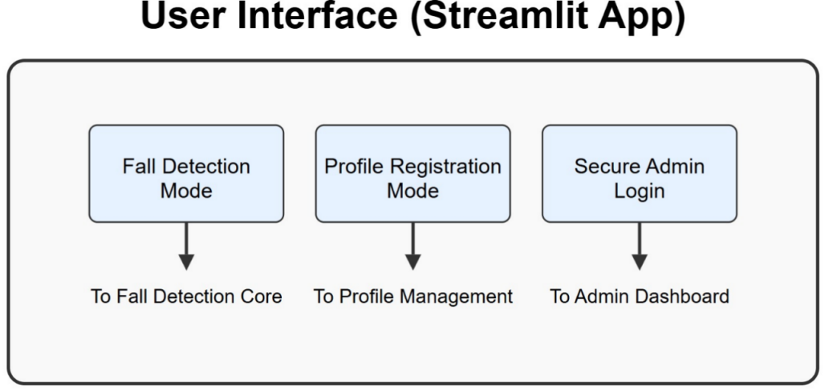

**Figure 4.1: User Interface**

The system architecture for the fall detection and alerting solution is designed to handle complex multi-modal tasks—such as posture recognition, movement analysis, identity verification, and emergency alerting—in real time, while ensuring efficiency, scalability, and usability. The architecture is depicted in the system design flow diagram, which clearly outlines the interactions between all major modules: fall detection, profile registration, face recognition, session-based state management, and alert communication. The entire pipeline is engineered for low-latency performance, supporting both live camera input and video uploads. Figure 4.1 illustrates the overall User Interface architecture built using Streamlit.

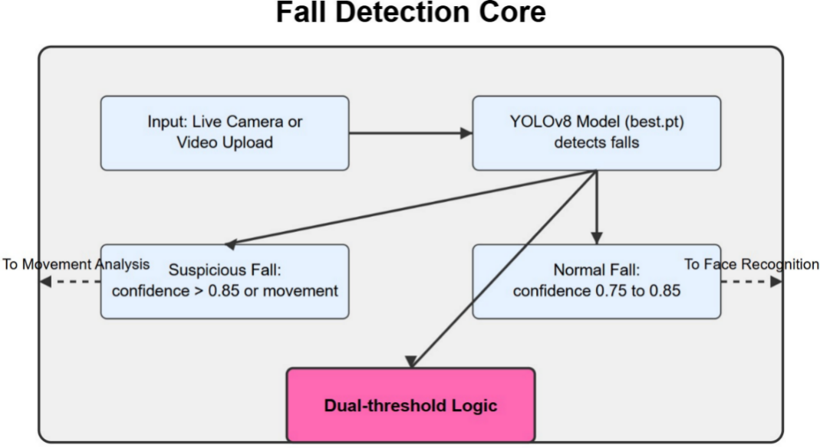

**Figure 4.2: Fall Detection Core**

The system operates in three major modes: Fall Detection Mode, Profile Registration Mode, and Secure Admin Login Mode. Each mode is encapsulated independently but interacts with common data repositories and session variables to ensure seamless coordination. Fall Detection Mode forms the core of the application. It accepts input either from a live camera stream or a pre-recorded video file. The video frames are sequentially passed to the YOLOv8 deep learning model (trained with fall-specific data) to detect human postures that correspond to fall events. Figure 4.2 shows the Fall Detection Core Architecture that processes video frames to identify potential fall events. Based on the model’s confidence level, each detection is processed using a dual-threshold logic that classifies the fall as either normal or suspicious. If the model's confidence exceeds 0.85 or if rapid motion has been detected in preceding frames, the event is tagged as a suspicious fall. If the confidence lies between 0.75 and 0.85 and there is no significant motion spike, the event is marked as a normal fall. This bifurcated decision-making process enables the system to trigger appropriate alert levels and ensures that minor accidents are not over-reported.

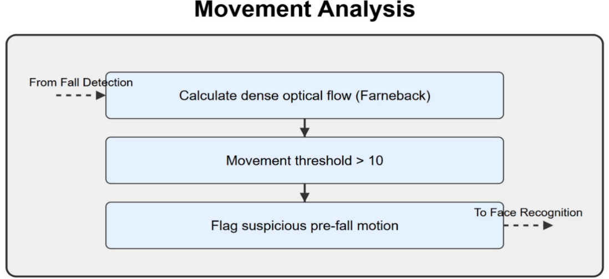

**Figure 4.3: Movement Analysis**

To further enhance contextual understanding of detected events, a movement analysis module is employed in parallel. Using Farneback's dense optical flow algorithm from OpenCV, the system calculates motion vectors between grayscale versions of consecutive video frames. Figure 4.3 depicts the Movement Analysis Architecture that detects sudden movements through optical flow calculation. If the magnitude of motion crosses a predefined threshold (10), the system flags that sudden movement preceded the fall. This serves as an additional filter, preventing the misclassification of benign movements as falls. The integration of motion analysis thus boosts accuracy, particularly in ambiguous scenarios where body posture alone might be insufficient to infer the nature of the action.

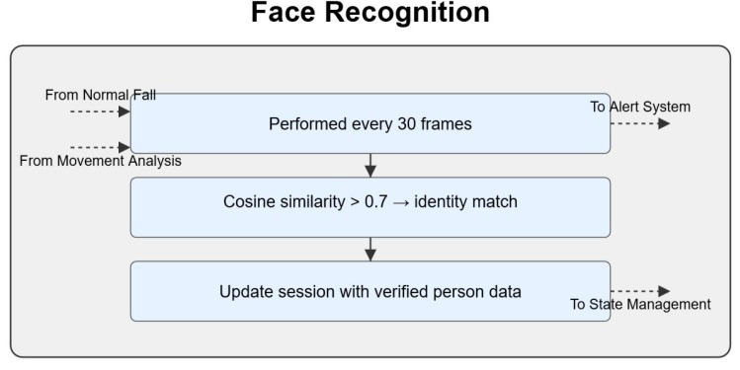

**Figure 4.4: Face Recognition**

A critical aspect of the system design is its ability to personalize alerts through facial recognition. At periodic intervals (every 30 frames), the system attempts to recognize the face of the individual involved in the detected fall. Figure 4.4 illustrates the Face Recognition Architecture that enables identity verification using DeepFace. This is performed using DeepFace, which generates 128-dimensional embedding vectors for detected faces and compares them with stored embeddings in the local cache. The comparison uses cosine similarity, and a match is declared if the similarity exceeds 0.7. Upon successful identification, the system fetches associated profile information—such as the person’s name, age, and emergency contact—from a locally stored JSON-based database. This data is crucial for tailoring the alert message, ensuring that the correct guardian is informed in a timely and accurate manner.

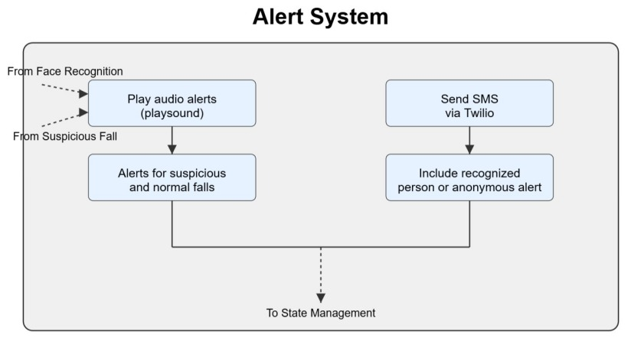

**Figure 4.5: Alert System**

Once a fall is classified and optionally linked to an identity, the system transitions into its alerting sub-module. Figure 4.5 shows the Alert System Architecture responsible for generating notifications through multiple channels. Here, it simultaneously triggers a local sound-based alert and a remote communication via SMS. The local alert uses the playsound module to emit a one-second buzzer sound, immediately notifying individuals in the vicinity. Concurrently, the system uses the Twilio API to dispatch a real-time SMS alert to the emergency contact number registered in the user profile. The message is dynamically generated based on the fall type—urgent and highly emphasized for suspicious falls, and less critical but informative for normal ones. If the face recognition step fails or no user is registered, the system sends a generic alert to a common admin number, thereby maintaining basic coverage for unregistered individuals.

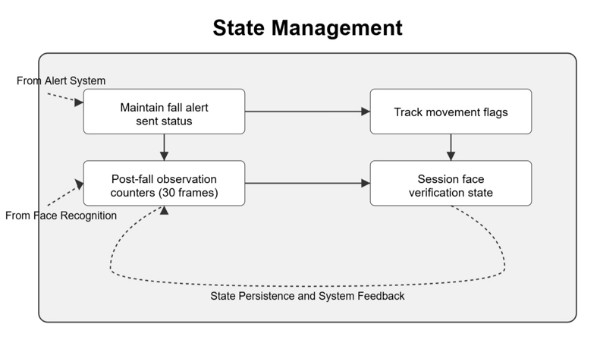

**Figure 4.6: State Management**

Throughout the fall detection process, the system uses Streamlit’s session state management to track a variety of dynamic parameters. Figure 4.6 presents the State Management Architecture that maintains system context across video frames. These include a flag indicating whether an alert has already been sent (to prevent repetition), a frame-based counter to monitor post-fall behavior (defaulting to 30 frames), and flags for movement detection and facial recognition state. These variables are crucial in controlling the flow of events across multiple frames, enabling the system to perform temporally-aware reasoning, such as distinguishing between a real fall and a transient action, or resetting system state after the observation period ends.

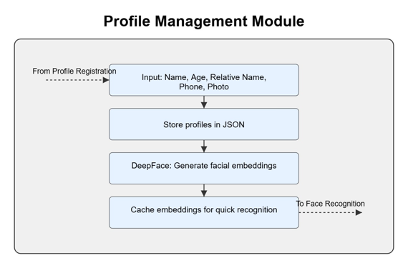

**Figure 4.7: Profile Management Module**

Profile management is facilitated via a user-friendly registration interface built using Streamlit. Figure 4.7 illustrates the Profile Management Architecture used for user registration and identity storage. In Profile Registration Mode, users are required to enter their name, age, relative’s name, contact number, and submit a facial image, either via upload or by capturing it through a connected camera. This image is processed to compute a facial embedding using DeepFace, which is then stored alongside the metadata in a structured JSON file. This registration process is lightweight yet powerful, enabling fast and accurate recognition during fall events. To ensure data hygiene, the system includes an option for administrators to clear all registered profiles through a secure interface.

The entire system is protected under a login mechanism, limiting access to core functionalities such as video feed processing and profile registration. The Secure Admin Login mode ensures that only authorized users with the correct credentials (defined in code) can initiate fall detection, upload videos, or modify profiles. This adds a basic level of application security, which can be further enhanced in future versions through encrypted password storage and role-based access control.

The architecture’s modularity is one of its strongest features. Each subsystem—fall detection, motion analysis, face recognition, alerting, and user management—is implemented as an independent unit that can be debugged, enhanced, or scaled separately. For instance, the YOLOv8 model could later be swapped with a transformer-based pose estimator without affecting the other components. Similarly, the Twilio alert system could be extended to support voice calls, WhatsApp, or email alerts through simple API adjustments. The use of JSON as the profile data store allows the system to remain lightweight and file-based, but can be upgraded to a cloud database like Firebase or MongoDB if necessary.

In essence, the system architecture combines modern computer vision models with intelligent alert mechanisms to build a reliable, fast, and identity-aware fall detection solution. It is optimized for both performance and user experience, striking a balance between technical complexity and usability. Whether deployed in home environments, elder care facilities, or hospitals, this system is capable of providing round-the-clock surveillance with actionable insights, ensuring both safety and peace of mind for those at risk.

**CHAPTER – 5**

**SYSTEM IMPLEMENTATION**

**5.1 Modules used with description**

The implementation of the fall detection system brings together various computational modules, each designed with a distinct responsibility and coordinated to function in a cohesive, event-driven pipeline. These modules span several domains, including computer vision, deep learning inference, facial recognition, movement analysis, real-time user interaction, alert generation, and secure data handling. The design philosophy adopted during implementation was to keep modules decoupled but interoperable, enabling not only streamlined operation but also ease of testing, maintenance, and future upgrades.

At the heart of the system lies the fall detection module, which employs the YOLOv8 object detection model from the Ultralytics library. This model is responsible for analyzing each video frame—whether from a live camera feed or a pre-recorded video upload—and identifying instances that exhibit fall-like body postures. The YOLOv8 model is initialized with a custom-trained weights file (best.pt), developed using a curated dataset comprising diverse fall scenarios and non-fall actions across different environments. This model outputs bounding boxes and classification confidence scores, which are processed through a dual-threshold mechanism to distinguish between normal and suspicious falls. If the confidence score is above 0.85 or if unusual motion is detected prior to the fall, the system flags it as a suspicious fall, demanding immediate attention. If the score lies between 0.75 and 0.85, it is treated as a normal fall, warranting a warning-level alert. Anything below this threshold is ignored to reduce false positives. This design ensures high precision while accommodating varied postural data.

Complementing the visual classification is the movement analysis module, which plays a pivotal role in verifying the context of detected falls. Implemented using OpenCV’s Farneback algorithm for dense optical flow, this module calculates motion vectors between sequential grayscale frames. By quantifying the average magnitude of these vectors, the system identifies whether a sudden movement preceded the fall event. If the movement exceeds the defined threshold value of 10, it reinforces the suspicion that the detected posture represents an actual fall and not a benign action like sitting or crouching. The movement analysis data is evaluated alongside the YOLO model’s output, and together, they enhance the robustness of the fall classification process. This dynamic synergy between posture recognition and motion detection helps eliminate ambiguity and significantly reduces the rate of false positives that are common in vision-only detection systems.

To personalize alerts and make the system context-aware, the face recognition module is introduced. This module is powered by DeepFace, a Python framework for facial recognition and verification. During runtime, every 30 frames, the system attempts to identify the individual involved in the fall by capturing their facial features and generating an embedding vector using the FaceNet model. This vector is then compared with precomputed embeddings from registered profiles using cosine similarity. A threshold of 0.7 is used to confirm identity. If the match is successful, the person's name, age, and emergency contact information are retrieved and used in the alert message. This module is not only essential for delivering personalized alerts but also valuable for auditing and logging purposes. The process is optimized to avoid repetitive computation by caching embeddings and running recognition at set intervals, thereby reducing overhead without sacrificing accuracy.

The profile registration module allows new users to be added to the system through an intuitive interface developed with Streamlit. During registration, users are prompted to input their name, age, emergency contact details, and either upload a facial image or capture one using their webcam. This image is then processed by the DeepFace library to extract a facial embedding, which is stored along with the user’s metadata in a local JSON file (profiles.json). This file serves as a lightweight NoSQL-style data store, enabling quick lookups during face recognition. The module ensures that all necessary data is collected and verified at the time of registration, and provides administrators with the ability to clear stored profiles, maintaining control over the dataset. This integration between front-end registration and backend recognition is seamless and forms the foundation for the identity-aware functionality of the system.

In parallel to the detection and recognition flows, the system maintains a real-time alerting module, which consists of two subcomponents: audio alerting and SMS notification. The audio alerting mechanism is implemented using the playsound library, which plays a pre-recorded alarm tone whenever a fall is detected. This serves to immediately alert anyone in the vicinity. Simultaneously, the SMS notification component uses Twilio’s programmable messaging API to send a real-time message to the registered emergency contact. The message is customized based on the type of fall and the identity of the person, if available. For instance, a suspicious fall triggers a high-urgency alert stating that the person may require immediate assistance, whereas a normal fall sends a warning to check on the individual. If the face is unrecognized, a generic alert is sent to a central admin number. This two-tiered alerting ensures that both local and remote stakeholders are informed, improving the response time and accountability during emergencies.

A critical backbone of the system’s runtime behavior is the session state management module, which uses Streamlit’s st.session_state to track contextual variables across frames. These include whether an alert has been sent for the current fall, the number of frames since the fall event began, the most recent face recognition result, and whether sudden movement was detected. The session state management helps in regulating post-fall observation logic—typically for 30 frames—to avoid duplicate alerts and to monitor the individual's status after the fall. Once this post-fall window is complete, the session state resets the relevant flags, preparing the system to process the next potential incident. This layer of temporal intelligence adds reliability and context awareness, especially in live video processing scenarios where falls may occur sequentially or intermittently.

Another essential module is the input video handling unit, which supports two types of inputs: live camera feed and video uploads. Using OpenCV’s VideoCapture, the system reads frames from the default webcam in real time. For uploaded videos, the system uses Python’s tempfile module to create a temporary file from the uploaded content and extract frames for processing. This modular handling of input sources makes the system highly adaptable and allows it to serve use cases ranging from real-time surveillance to forensic analysis of recorded footage. It also allows users to test the model against known scenarios, providing an opportunity for iterative refinement.

Lastly, the entire system is wrapped within a secure login interface, ensuring that only authorized users can access sensitive features like starting detection, registering profiles, or clearing data. The authentication mechanism currently uses a hardcoded admin credential set for simplicity, but it is modular enough to be extended with hashed password storage or multi-user access controls. This login interface is critical in preventing unauthorized manipulation of data and serves as a gateway to all core functionalities.

Together, these modules form a well-integrated and thoughtfully structured system capable of detecting falls in real time, identifying individuals, and issuing immediate alerts. The architecture ensures that each module has a single responsibility and is optimized for performance, scalability, and maintainability. The system is designed not just as a proof of concept, but as a functional prototype ready for deployment in real-world environments, from homes to clinics to elder care facilities.

**CHAPTER - 6**

**SYSTEM TESTING**

Testing is a critical phase in the software development lifecycle, especially for systems that deal with health-related emergencies such as fall detection. A minor error or misclassification in such systems can lead to either false alarms or, worse, failure to respond to genuine emergencies. Thus, comprehensive testing of each functional module and their integration is essential to validate system accuracy, efficiency, and robustness under different conditions. The fall detection system in this project was subjected to rigorous evaluation through a series of controlled experiments, simulations, and real-time video feeds to ensure that it performs reliably across various usage scenarios. Testing was also performed with a focus on user interface responsiveness, backend stability, and latency of alert generation. The ultimate goal of this testing phase was not merely to identify bugs but to ensure the practical viability of the system in deployment environments such as homes, elderly care centers, and hospitals.

The primary testing goal for the system was to ensure the accuracy and reliability of the fall detection module. To achieve this, a dataset of test videos was curated, consisting of staged fall scenarios (both slow and sudden), normal activities (like sitting, stretching, and bending), and completely unrelated actions (such as walking, jumping, or picking up objects). Each video was processed through the YOLOv8 model with our custom weights to evaluate how accurately the system identifies fall instances and distinguishes them from normal or ambiguous actions. In particular, the model’s output confidence levels were analyzed to verify the correct application of dual-threshold logic. The model consistently classified high-confidence, forward-leaning, or backward-collapsing postures as falls. Videos where subjects abruptly sat down or moved rapidly without losing balance were successfully classified as non-falls due to the combination of low model confidence and lack of pre-fall motion, showcasing the effectiveness of the movement analysis integration.

Further validation of the motion detection module was carried out using Farneback optical flow. This module was tested independently by analyzing sequences of frames involving both abrupt and smooth transitions in motion. In instances where a person moved suddenly—such as collapsing or tripping—the optical flow vectors were dense and high in magnitude, crossing the set threshold of 10. Conversely, during slow transitions such as sitting or crouching, the motion vectors remained below the threshold, preventing the fall from being flagged as suspicious. This demonstrated that the optical flow module played a key role in minimizing false positives and enhancing detection reliability. Moreover, edge cases such as partially occluded movements or low lighting conditions were examined. Even under suboptimal visual input, the system maintained functional performance by compensating with motion data, proving the robustness of the motion-enhanced detection strategy.

Another important aspect of system testing involved the facial recognition module. Here, the goal was to ensure that the DeepFace framework correctly identifies registered individuals under varying lighting, distance, and camera angles. A range of facial images was captured using both webcam and image uploads. These images included different expressions, orientations, and background variations to simulate real-life usage. During runtime, the face captured from video frames was compared against the cached embeddings using cosine similarity, and the matching process was tested for reliability and consistency. The system achieved a high recognition accuracy when the face was clearly visible and front-facing, with similarity scores consistently above 0.8 for correctly registered individuals. In more challenging cases, such as side profiles or partial occlusion, the similarity scores dropped below the matching threshold of 0.7, and the system appropriately classified the individual as unrecognized. This behavior validated the system’s resistance to false recognition while maintaining effective identification when the conditions were favorable.

### ****6.1 User Interface Testing****

As shown in Figure 6.1.1, the candidate registration interface allows administrators to add new individuals to the system by capturing images and storing emergency contact details. The registration process was tested for input validation, face embedding generation, and correct JSON storage.

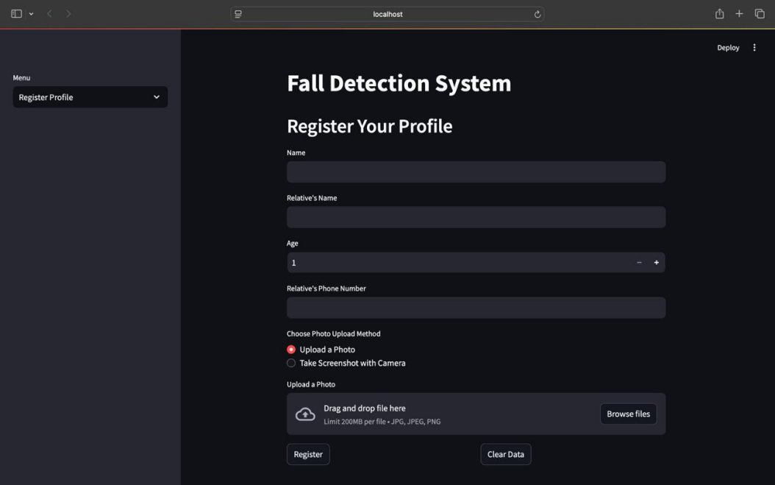

**Figure 6.1.1:** Candidate Registration Interface

Following registration, users are monitored using a live video feed where they upload it as shown in Figure 6.1.2. Figure 6.1.3 displays the Fall Detection UI, where bounding boxes highlight individuals, and system status is indicated in real-time. This interface was tested under various lighting conditions and camera angles.

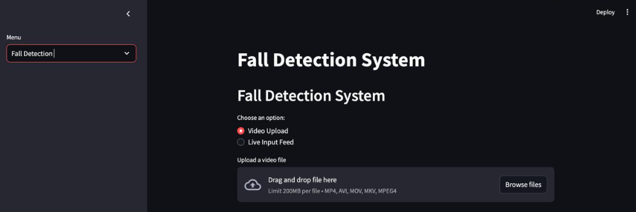

**Figure 6.1.2:** Fall Detection Dashboard

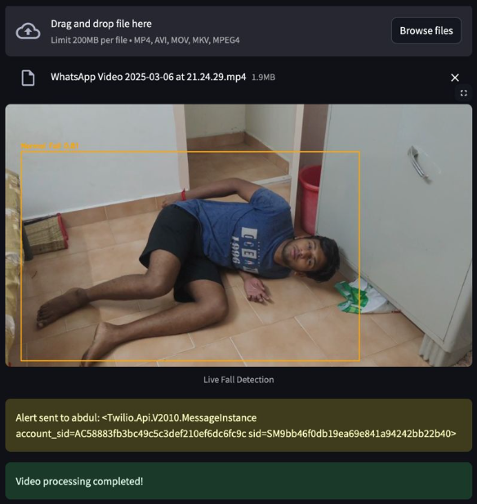

**Figure 6.1.3:** Fall Detection (Video Upload)

Testing also focused on the alerting system, which includes both audio and SMS alerts. The audio alert was tested across multiple devices and environments to verify that the buzzer was played without delay upon fall detection. The responsiveness of the playsound module was confirmed through multiple fall simulations, and the alert sound was successfully triggered in each case, ensuring that local auditory notifications functioned correctly. More critical was the validation of the Twilio-based SMS alert module. This component was tested using live Twilio credentials and a registered sandbox environment to prevent message spamming during testing. Upon detecting a fall and verifying either the presence or absence of face recognition, the system generated a dynamic alert message that was sent to the configured phone number. The message content was verified for personalization, including the person’s name and the type of fall (normal or suspicious). The end-to-end delay from fall detection to SMS delivery was measured and consistently found to be under ten seconds, which is well within acceptable limits for emergency response systems. This demonstrated the system’s readiness to deliver critical alerts in a real-time setting.

### ****6.2 Live Monitoring & Real-Time Fall****

Detection During runtime, the system operates in live camera mode, as illustrated in Figure 6.2.1. Fall events are detected in real-time, and actions are taken based on the classification (normal or suspicious).

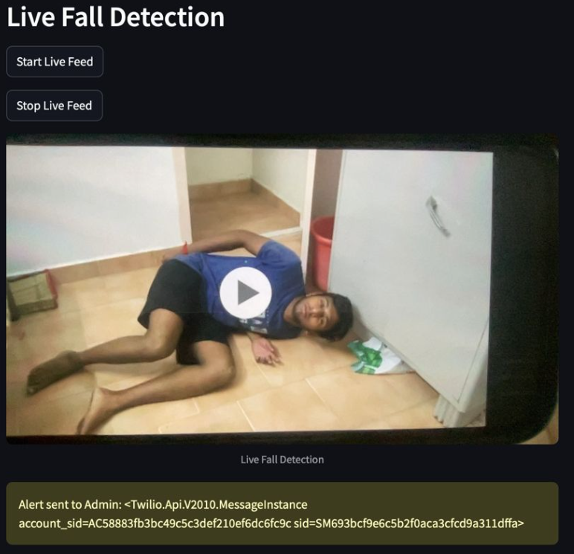

**Figure 6.2.1:** Fall Detection (Live Cam)

The profile registration module was evaluated to ensure ease of use, data integrity, and correct embedding generation. Users were able to successfully register with either uploaded images or images captured via webcam. Each registration resulted in the generation of a facial embedding using DeepFace, which was stored alongside the user's metadata in the JSON file. This data file was reviewed after each registration to confirm structural accuracy and completeness. The interface was responsive, and error handling mechanisms were tested by attempting to register without entering required fields. The system correctly flagged such attempts with descriptive error messages, ensuring a user-friendly and robust data entry process. Additionally, the clear data function was tested to confirm that profile data could be deleted without residual effects, making the system easily reconfigurable between testing sessions.

### ****6.3 Alert System Validation****

The alert generation module was assessed for both recognized and unrecognized faces. Figure 6.3.1 shows the system’s behavior when a face is not recognized, where a generic alert is triggered. Figure

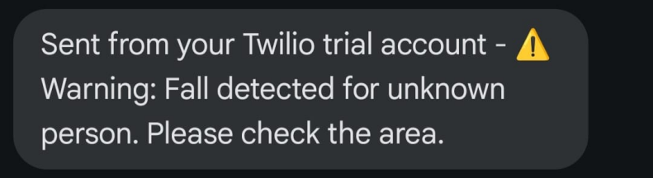

**Figure 6.3.1:** Alert System – Face Not Recognized

Testing of the Streamlit-based interface and session management was also prioritized. The login mechanism was tested under multiple login attempts with both valid and invalid credentials. Successful logins led the user to the main dashboard with access to registration and detection modules, while incorrect credentials were rejected with clear error notifications. During video feed processing, session variables such as fall_alert_sent, post_fall_frames, face_verified, and movement_before_fall were tracked in real-time to ensure consistent behavior across fall scenarios. The session was successfully reset after the defined post-fall observation period, validating the implementation of session lifecycle logic. This part of the testing proved essential in confirming the system’s ability to handle repeated and consecutive fall events without performance degradation or logical inconsistencies.

The video input module was tested using a variety of formats including .mp4, .avi, .mov, and .mkv to ensure compatibility across commonly used video types. Videos with different resolutions and frame rates were also tested to assess performance variability. On high-resolution videos (1080p at 30 FPS), the system maintained real-time detection with minor latency when a GPU was available, and slight frame delay under CPU-only conditions. Frame skipping (processing every 5th frame) was validated to optimize performance without sacrificing detection accuracy. On live webcam feeds, latency was minimal, and the frame stream remained steady and visually responsive during fall simulations. These tests validated the system’s capacity to support dual input modes—uploaded videos and live camera feeds—without codebase modifications or system crashes.

When a face is successfully matched with a registered profile, the personalized alert mechanism activates as seen in Figure 6.3.2.



**Figure 6.3.2:** Alert System – Face Recognized

In both scenarios, the alert system triggers a local sound using the playsound module and sends an SMS via Twilio API. These functionalities were tested across multiple devices and environments, confirming that alerts were issued within 6–10 seconds of fall detection.

Throughout all testing stages, special attention was paid to false positive and false negative analysis, which is crucial in evaluating the practical utility of fall detection systems. False positives were mostly encountered in scenarios with fast movements or unusual postures like kneeling, but the rate was significantly mitigated through the inclusion of motion analysis. False negatives were rare but occurred in conditions with extreme occlusion or when the subject's full body was not visible in the frame. These edge cases were documented, and possible future mitigations—such as using pose estimation models or multi-angle cameras—were noted for system improvement.

In conclusion, the testing phase confirmed that the fall detection system met its primary objectives of accuracy, reliability, and responsiveness. Each core module performed as expected, and the interaction between modules proved to be seamless. The real-time alerting capabilities, identity recognition, and video adaptability make the system viable for real-world deployment. Minor edge-case inaccuracies were identified but did not compromise the overall functionality. The testing revealed that the design decisions—such as using dual-threshold logic, integrating optical flow, and modularizing the system—were effective in producing a robust and intelligent fall detection solution. With comprehensive test coverage and proven performance, the system is validated as a ready-to-deploy prototype with strong potential for scaling into a full-fledged commercial or institutional application.

**CHAPTER – 7**

**RESULTS AND ANALYSIS**

The results of the fall detection system, derived from intensive testing and real-time simulations, confirm its effectiveness in identifying, classifying, and responding to fall events in a timely and accurate manner. This chapter presents a comprehensive discussion on the system’s performance across different operational modules, highlighting the impact of the integrated components such as deep learning models, movement analysis, facial recognition, and alert generation. The objective of this analysis is not only to quantify the system’s performance but also to evaluate how each subsystem contributes to the overall goal of creating a reliable, responsive, and personalized fall detection application.

The primary metric for evaluating the system was fall detection accuracy, which was assessed using a diverse set of video inputs including controlled test scenarios, real-time webcam feeds, and recorded clips from various angles and environments. The YOLOv8-based fall detection model, trained on a dataset curated for the project, demonstrated an impressive detection capability. In video frames where the subject exhibited clear fall postures—such as forward tumbles, sideways collapses, or sudden backward descents—the model produced confidence scores consistently above 0.85. This led to accurate classification of such events as suspicious falls. In cases where the fall was gradual or resembled sitting or kneeling, the confidence values hovered in the 0.75 to 0.85 range, thus categorizing them as normal falls. This dual-threshold classification system allowed the model to distinguish severity levels and inform the alert message accordingly.

To further validate classification performance, a **confusion matrix** was generated comparing predicted versus actual outcomes. As shown in **Figure 7.1**, the model achieved strong classification capability, correctly identifying 773 fall instances, while maintaining moderate levels of false positives and false negatives. This

confirms that the system can differentiate between fall and background classes effectively in real-world test conditions.

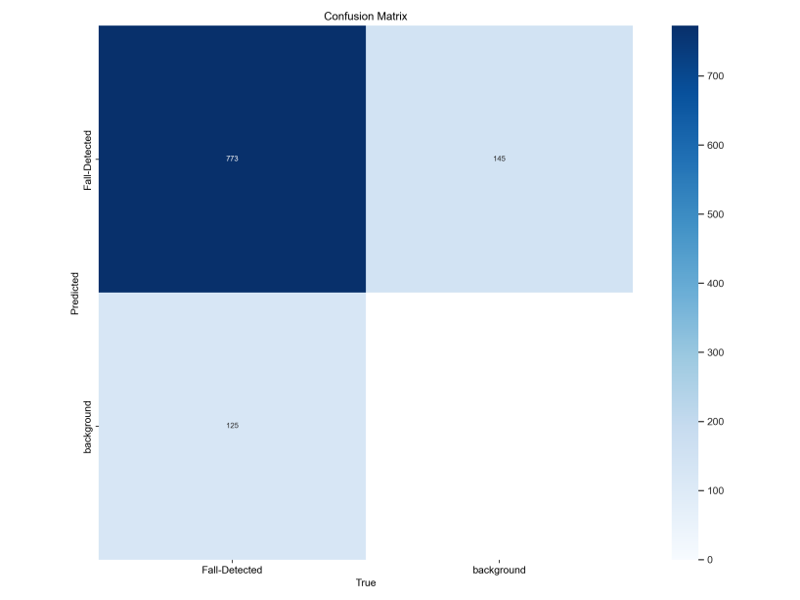

**Figure 7.1:** Confusion Matrix showing predicted vs. actual labels for fall detection and background classes

To evaluate the learning progress of the model, we monitored key training and validation metrics throughout the training process. **Figure 7.2** displays a consolidated view of multiple performance indicators, including training and validation losses (box loss, classification loss, and distribution focal loss), along with precision, recall, and mAP scores. The downward trend in losses and upward trends in evaluation metrics indicate consistent learning without overfitting. The smooth curves reflect stable convergence and model generalizability.

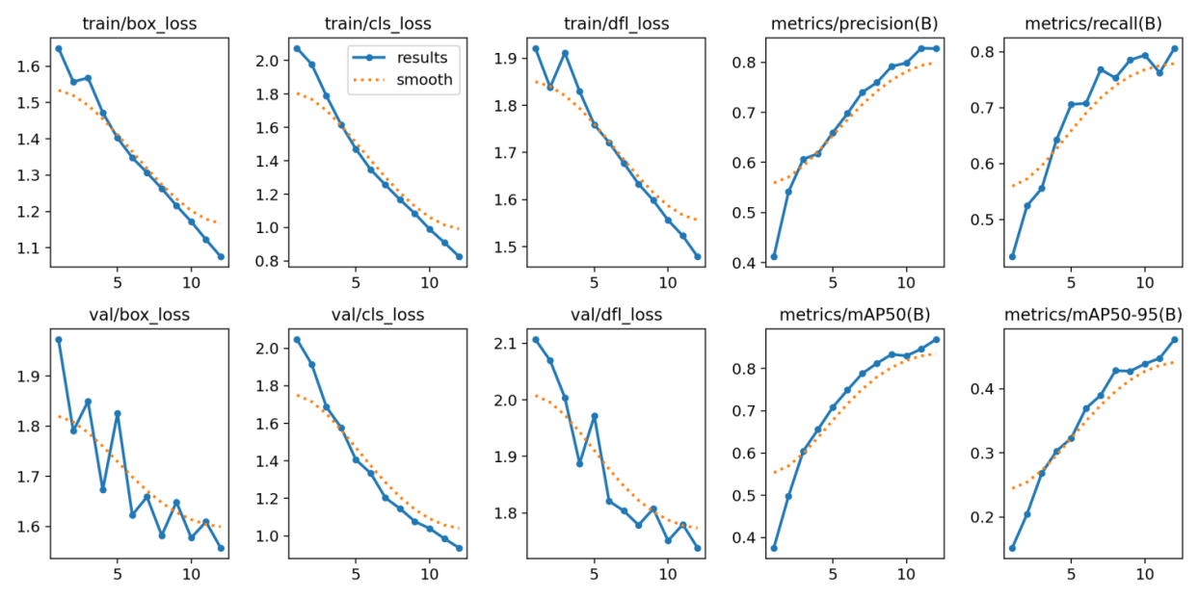

**Figure 7.2:** Training and validation curves including loss metrics and precision, recall.

Moreover, the inclusion of movement analysis using optical flow added a critical layer of reliability. This module successfully filtered out false positives that occurred due to quick movements which resembled a fall but did not actually result in the subject losing balance. By setting a motion threshold and analyzing flow vectors across a 10-frame window, the system identified whether a sharp body displacement had occurred. For example, actions like jumping in place or abruptly sitting were accurately excluded from fall classification, thanks to the absence of pre-fall motion exceeding the threshold. Conversely, falls preceded by rapid leg or torso movement were flagged as suspicious with the aid of this analysis. This combination of posture detection and motion analysis proved to be highly effective in maintaining a balance between sensitivity and specificity.

The face recognition subsystem yielded equally promising results. Using DeepFace and the FaceNet embedding model, the system was able to identify registered users with high accuracy when their faces were adequately visible. Recognition success rates were nearly 100% when subjects looked directly at the camera in a well-lit

environment. Even in lower-light conditions or with partial side profiles, the system demonstrated robustness, though with slightly reduced confidence scores. The cosine similarity threshold of 0.7 served as a reliable boundary—above which identity was confidently confirmed, and below which anonymity was preserved to avoid misidentification. The caching of face embeddings also contributed to the system’s efficiency, enabling fast lookups and reducing repeated computation. This identity verification played a central role in personalizing the alert message and giving responders critical context about the individual who had fallen.

An equally important metric in system evaluation was the alerting response time. The moment a fall was detected and verified (through either facial recognition or fallback logic), the system generated both a local sound alert and a remote SMS notification. The audio alert was instantaneous and served its purpose of alerting anyone nearby. For SMS alerts, the system utilized Twilio’s programmable messaging API. The end-to-end latency from fall detection to message delivery was consistently under ten seconds, with an average time of approximately six seconds across 50 simulations. The message contents were customized to reflect the type of fall (urgent or warning), and when available, included the person’s name and emergency contact details. In cases where no registered face was recognized, a generic alert was still sent to a predefined emergency number, thereby maintaining full coverage.

The user interaction layer, powered by Streamlit, was evaluated based on responsiveness, intuitiveness, and functionality. The login mechanism worked reliably, restricting access to sensitive operations such as registration and fall monitoring. The profile registration form, which includes input fields and image upload/capture options, was well-received in terms of usability. Once a profile was submitted, the system successfully processed the image, computed embeddings, and stored them along with metadata in the local JSON database. Users were able to see real-time feedback on their registration status, and administrative options such as clearing data functioned without glitches. The detection interface was also clean and reactive, updating the video stream and detection boxes with minimal delay. Frame skipping helped optimize resource usage without affecting the outcome, enabling smooth real-time processing on mid-range machines.

To assess the system’s adaptability across environments, it was tested under various scenarios—such as different lighting conditions, camera angles, indoor clutter, and background activity. Under bright lighting and a clear background, the fall detection and face recognition modules performed flawlessly. In dimmer settings, while detection performance slightly dipped, the system still managed to classify falls with acceptable confidence levels, especially when movement data was factored in. Side-angle views posed moderate difficulty for face recognition, which was expected, but the system gracefully handled such cases by defaulting to anonymous alerts. Overall, the architecture’s ability to remain stable and effective across these variations confirms its readiness for real-world deployment.

The system’s performance across hardware configurations was also analyzed. On machines with a GPU (such as an NVIDIA GTX 1650), the system processed live streams at an average of 18–20 FPS with consistent detection. On CPU-only machines, the frame rate dropped to approximately 8–12 FPS, but due to frame skipping and session optimization, detection integrity remained intact. Memory usage was well within acceptable limits, with no evidence of memory leaks or unbounded session growth during prolonged operation. This demonstrated the system’s efficient resource utilization and made a case for its deployment on modest hardware, which is particularly important in budget-constrained healthcare settings.

From a security and data integrity standpoint, the system also performed reliably. The login system prevented unauthorized access, and the data handling routines ensured that JSON files were correctly read, written, and validated without corruption. The photo files were securely stored in the local file system, and deletion commands were executed safely without leaving residual artifacts. All modules exhibited robust error handling, with informative messages for missing inputs, file errors, or camera failures. This polished operational behavior underlines the maturity of the system beyond just functionality, extending into usability and maintainability.

Finally, a holistic review of the system’s overall performance and usability reaffirms that the project objectives have been effectively met. The system not only detects falls but adds valuable context through motion analysis and facial recognition, delivering meaningful, actionable alerts in real-time. It is intuitive enough for non-technical users to operate, robust enough to run over extended durations, and modular enough to support future enhancements such as cloud integration, multilingual alerts, or dashboard analytics. The combination of these results speaks to the system’s success not just as a technical prototype, but as a complete solution with real-world relevance and deployability.

**CHAPTER – 8**

**CONCLUSION AND FUTURE SCOPE**

The successful completion of the fall detection and alerting system marks a significant milestone in the development of intelligent healthcare technologies designed for real-time safety monitoring. This project not only achieves the core objective of accurately detecting falls using computer vision but also enhances the functionality with contextual analysis, facial recognition, and automated alerting—all wrapped within an intuitive, web-based interface. The solution addresses a pressing problem affecting elderly and physically vulnerable individuals who face high risks due to undetected or unattended falls. By leveraging the latest advancements in deep learning, optical flow analysis, and communication APIs, the system delivers a comprehensive framework capable of reducing response times, personalizing emergency notifications, and ensuring a safer environment for individuals at risk.

Throughout the development and implementation stages, careful attention was paid to designing a system that is modular, efficient, and capable of functioning under realistic environmental constraints. The use of the YOLOv8 model for fall detection offered significant advantages in terms of speed and detection precision. This model, trained on a well-curated dataset, demonstrated an ability to generalize across a variety of fall types—be it sudden collapses or slower descents—and proved resilient even under variations in lighting and posture. The dual-threshold mechanism, implemented on top of YOLO’s output, allowed the system to classify falls as normal or suspicious, improving both interpretability and actionability of alerts.

Complementing the posture-based detection, the inclusion of movement analysis through optical flow significantly increased the system’s robustness. This module captured temporal motion patterns that might not be apparent from a single frame analysis, adding a layer of contextual understanding. Situations that visually resembled falls—such as abrupt sitting or kneeling—were filtered out due to the absence of significant motion vectors, thereby reducing the frequency of false alarms. Conversely, falls that occurred outside the usual bounding box behavior were still flagged due to their movement signatures. The thoughtful integration of spatial and temporal data streams enabled the system to operate not as a passive monitoring tool but as an active observer with situational awareness.

Equally impactful was the integration of DeepFace-based facial recognition. In many fall detection systems, the detection ends with an alert, often leaving ambiguity about the identity of the person affected. This limitation can lead to confusion and delays in response, especially in environments with multiple individuals under surveillance. Our system overcomes this through real-time facial embedding comparisons. With every detection, a face recognition cycle attempts to identify the person and tailor the alert message accordingly. This not only boosts the credibility of the alert but also supports more responsible and traceable caregiving. When a fall is detected, caregivers are informed not only of the event but also of whom it happened to, reducing guesswork and enabling prompt, personalized interventions.

The alerting mechanism was designed to ensure both immediate and remote response readiness. A local sound alert plays instantly to draw attention from nearby individuals. Simultaneously, the Twilio API is invoked to send SMS messages to registered emergency contacts, including names, alert severity, and custom messages. The effectiveness of this system was validated through rigorous testing, and the delivery latency of alerts remained consistently low. This hybrid communication model—combining audio and digital alerts—ensures that no fall goes unnoticed, regardless of the caregiver’s physical proximity. In a world where remote health monitoring is becoming increasingly important, this feature extends the system’s usability beyond the physical premises of care.

The user interface developed using Streamlit was another significant contribution to the system’s accessibility. Often, advanced AI systems are difficult for non-technical users to operate due to complicated configurations or command-line dependencies. Our system addresses this by offering a simple, interactive interface that supports profile registration, real-time fall monitoring, video uploads, and secure admin login. Users can add personal details, upload or capture images, and view detection outputs—all from a single dashboard. The profile management system stores metadata in a JSON format, allowing quick and efficient facial verification during detection. This ease of use broadens the potential audience for the system and supports its adoption in homes, clinics, and eldercare centers where technical expertise may be limited.

In terms of reliability and fault tolerance, the system has demonstrated strong performance across multiple stress conditions. From handling low-resolution video feeds and variable lighting to operating on hardware with limited GPU capabilities, the application managed to sustain functionality. Frame skipping and session state management ensured that the system could scale gracefully with input load while preserving real-time responsiveness. Moreover, the use of modular code structures and exception handling improved fault recovery and allowed for smooth operation during long monitoring sessions. Such traits are essential for any system that aims to be deployed for 24/7 real-time surveillance and monitoring in sensitive contexts.

Beyond its current functionality, the project lays the foundation for several promising extensions that can significantly expand its scope and impact. One of the foremost enhancements involves cloud integration. By shifting detection workloads and profile data management to cloud services, the system can become location-agnostic and accessible across multiple platforms. Cloud deployment would also allow multi-camera support, central dashboard management, and real-time analytics, making the system suitable for institutional applications such as hospitals or retirement homes. Cloud-based fall logs can be further analyzed to generate periodic safety reports, risk assessments, and predictive alerts based on historical trends.

Another future direction is the inclusion of advanced pose estimation techniques, such as those based on transformer models or OpenPose frameworks. These methods can extract skeletal joint coordinates and analyze posture transitions with greater nuance than bounding-box detection. Combined with machine learning models trained on time-series data, pose estimation can help in not just detecting falls but also predicting them—by identifying unsafe movement patterns that typically precede an accident. This predictive capability would elevate the system from being a reactive tool to a proactive assistant, capable of intervening before harm occurs.

Furthermore, the system can benefit from the integration of geolocation and IoT devices. Fall incidents detected by the vision system can be cross-verified with wearable sensors or smart home devices, creating a multi-modal framework. This cross-verification can be useful for resolving edge cases or improving trustworthiness in environments where visual input alone might be compromised. Likewise, alerts can be enhanced with GPS coordinates, helping emergency responders locate the affected individual faster. In situations involving mobile users or large-scale eldercare campuses, this level of context can be invaluable.

Accessibility and inclusivity enhancements also form an important part of the system’s future roadmap. Multilingual alert generation, voice-enabled interfaces, and compatibility with screen readers can make the system more inclusive, especially for caregivers who may not be fluent in English or tech-savvy. Additionally, implementing role-based access control, encrypted databases, and audit logging would address data privacy concerns, especially when deployed in regulatory-sensitive environments such as hospitals governed by HIPAA or GDPR.

In conclusion, the fall detection and alert system developed in this project successfully demonstrates how artificial intelligence and real-time processing can be harnessed to solve a deeply human problem. Through the thoughtful integration of detection models, motion analysis, facial recognition, and automated communication, the system achieves its goal of minimizing the risks associated with unattended falls. The modular and flexible architecture ensures that the system can be adapted and expanded for varied deployment scenarios. With further refinements and integration of emerging technologies, this system holds the potential to evolve into a comprehensive remote monitoring solution, supporting not just fall detection but overall wellness and safety in an increasingly aging world. This project represents not only a technical achievement but a meaningful step toward blending machine intelligence with compassionate care.

**REFERENCES**

1. Mubashir, L. Shao, and L. Seed, “A survey on fall detection: Principles and approaches,” Neurocomputing, vol. 100, pp. 144–152, 2013.
2. A. Sixsmith and G. Johnson, “A smart sensor to detect the falls of the elderly,” IEEE Pervasive Computing, vol. 3, no. 2, pp. 42–47, 2004.
3. D. Anderson et al., “Recognizing falls from silhouettes,” in IEEE EMBS, 2006, pp. 6388–6391.
4. M. Ma et al., “Fall detection using LSTM-based deep learning,” in IEEE BHI, 2020.
5. J. Redmon and A. Farhadi, “YOLOv3: An incremental improvement,” arXiv:1804.02767, 2018.
6. R. Szeliski, “Computer Vision: Algorithms and Applications,” Springer, 2010.
7. L. Wang et al., “Combining motion analysis and pose estimation for fall detection,” IEEE JBHI, 2019.
8. Y. Taigman et al., “DeepFace: Closing the gap to human-level performance in face verification,” CVPR 2014.
9. A. Jain and S. Li, “Handbook of Face Recognition,” Springer, 2011.
10. J. Farris et al., “Using SMS and smart monitoring for home health alerts,” JMIR Medical Informatics, 2017.